Is Lactic Acid to Blame for Olympic Pain?
Sports scientists have been saying it for a long time but more and more evidence is coming out that supports endurance training turning lactic acid into a friend - not a foe! Lots of literature and research exists around LACTIC ACID, ANAEROBIC THRESHOLD, LACTATE THRESHOLD, MAX LACTATE STEADY STATE, the LACTATE INFLECTION POINT (LIP) & LACTIC ACID / LACTATE TOLERANCE. Often these terms are incorrectly used inter-changeably.
For the purposes of VCE Physical Education, it is expected that students should be able to:
- define the term LIP
- identify the LIP on a graph
- understand why lactate accumulates beyond LIP
- describe the impact of exercise intensities beyond LIP on fatigue
- identify the differences in LIP between a trained and an untrained athlete
- describe how training can improve LIP

Click on the link to the BBC article: http://www.bbc.co.uk/news/health-19194806 and have a go at the following questions:

QUESTION 1. In your own words – describe what is occurring at the lactate inflection point and what happens just after this point?

QUESTION 2. “Lactic acid is a by-product when the muscles use carbohydrates to create energy for exercise. Lactic acid then breaks down into hydrogen ions and lactate, and it's the hydrogen ions that cause the pain” Dr Steve Ingham
- Which energy system is being called upon to increase its contribution to energy supply when LIP occurs?
- What is the difference between “aerobic glycolysis” and anaerobic glycolysis”?
- Of the following 2 processes, which one has the greatest capacity: “aerobic glycolysis” or “ anaerobic glycolysis?

QUESTION 3. "Athletes can go for longer before the breakdown products of metabolism start causing problems. They can work harder for longer to produce the same amount of lactate in the bloodstream - and cope with it better." Dr Tom Shaw

- What is Dr Shaw implying about a chronic adaptation endurance trained athletes develop in relation to LIP?
- List one cardiovascular, one respiratory and one muscular adaptation that occur as a consequence of endurance training and discuss how these contribute to athletes being able to “work harder for longer to produce the same amount of lactate”.

Hint : “The key to getting rid of pain-inducing hydrogen ions is simply to train harder, although some people, like Redgrave and Sir Matthew Pinsent, are just genetically predisposed to being 'big engines'. These are athletes who can get rid of hydrogen ions, by breathing in oxygen and creating more energy.”

- “Coping with lactate better” is centred around the notion of improved lactate tolerance – how does this occur?

QUESTION 4. “Dealing with the muscle pain differs from sport to sport, but the key is to keep the muscles moving. You see cyclists going straight on to stationary bikes after their races to recover”. Dr Tom Shaw
- Why is an active recovery recommended following activities that result in large amounts of H+ accumulating.
- The article suggests that rowers need to be assisted from their boats following the 2000m event - use the lactate shuttle principle to explain why this is the case.

QUESTION 5. “The GB rowing squads are tested on their lactate thresholds - how much effort they can put in before the lactic acid builds up. The slower it builds up the better," Dr Tom Saw
- Discuss why the GB rowers might deliberately stay at or slightly below their LIP during training sessions?
- On other occasions the GB rowers would deliberately work at, or slightly above their LIP during different training sessions – what are they aiming to achieve from this that is different from the training listed in (i) above?
- During Olympic finals, some teams aim to stay just below the stroke rating that would surpass their LIP for as long as they can and then increase this in the later stages of the race – why?

QUESTION 6. “In elite athletes, lactic acid starts to build up when they are operating at somewhere between 80% and 90% of their maximum heart rate.” Dr Tom Shaw. The following graph shows the hypothetical accumulation of lactate at various intensities, in both slow and the two types of fast twitch fibres.
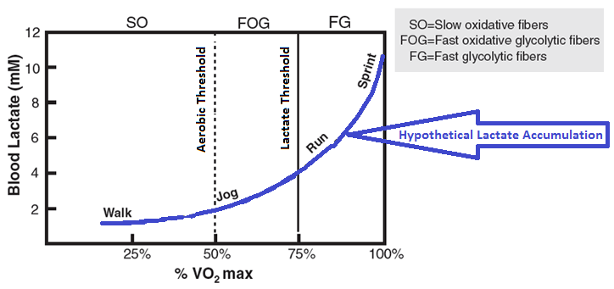
- On the graph above, draw a line to represent the blood lactate for marathon runner using the %VO₂ max intensities provided?
- Draw another line to represent the blood lactate for Usain Bolt running at the same intensities as the marathon runner.
- Discuss reasons for the differences that may exist.
EXTENSION CONSIDERATION:
“They say that intense training teaches the body to use lactic acid as a source of fuel on a par with the carbohydrates stored in muscle tissue and the sugar in blood. Lactate can then be burned with oxygen to create even more energy. This efficient use of lactic acid not only prevents lactate build-up, it ekes out more energy from the body's fuel.” University of California
- What are carbohydrates stores at muscles known as?
- Sugar in the blood is known as________________?
- How can lactic acid actually be used to create more ATP and “ekes out more energy” ?
- Endurance training can lead to “glycogen sparing” – Discuss what happens to allow for improved performances.

